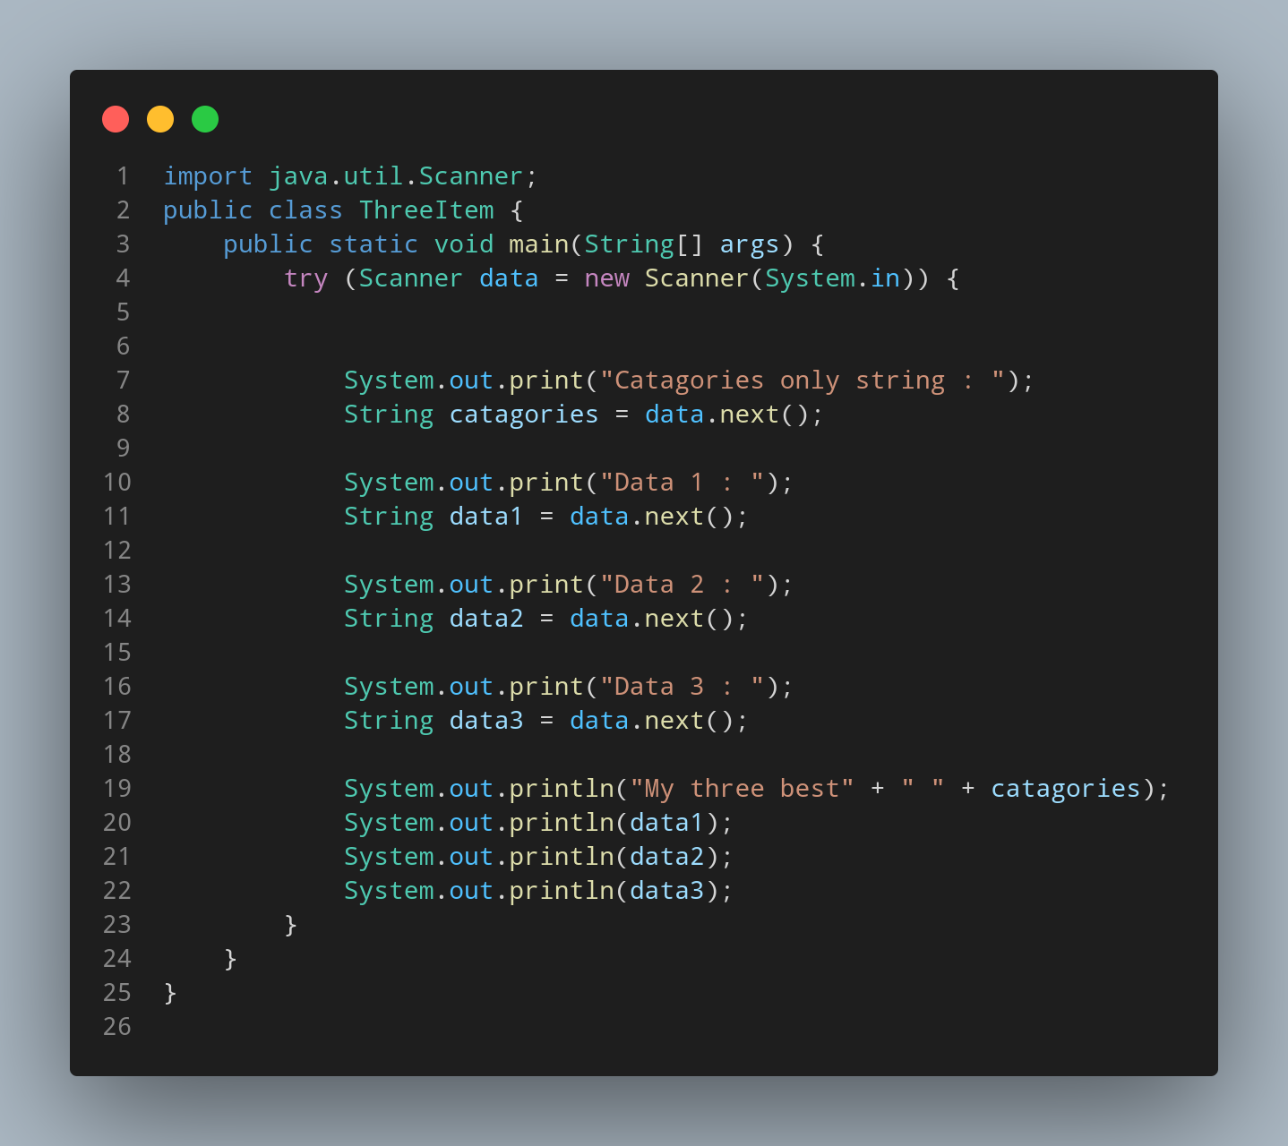

#Doc

First we import import java.util.Scanner to use scanner function.

File name ThreeItem is created so we create a class name ThreeItem, inside the class we created a main function.Instantiating scanner class as data name. Then we print a message for our user to input there Catagoriesd of data. Using data.next() it allows user to input there data and store in cagories variable having data type String. In same way 3 more data are entered related to the catagories user want.Then user given data are printed along with the appropriate string to make it useful output.

